Lab Report

ECPE 170 – Computer Systems and Networks – Spring 2017

Name: STEVE GUERRERO

Lab Topic: PERFORMANCE OPTIMIZATION (LAB #: 06)

What is the total physical RAM installed in the system? (In MB)
16,178 MB
(2) With no applications running (beyond the web browser with this page), how much RAM is used by the
native operating system? (e.g. Windows)
3.8 GB
(3) With no applications running (beyond the web browser with this page), how much RAM is available?
12 GB
(4) Check the virtual machine configuration. How much RAM is currently allocated to Linux in your virtual machine?
Note: Your answer to question 4 must be less than your answer to question 3! Otherwise, your system will use slow virtual memory (i.e. swapping data to the hard disk) when running this lab.
1982 MB
(5) Try to increase your virtual machine memory allocation, if possible, to the maximum allowed based on your free RAM. Leave ~256MB free for the virtual machine program itself. Now how much RAM is allocated to Linux in your virtual machine?
I allocated 4096 MB, now there is 2511 MB free.
(6) Boot Linux. With no applications running in Linux, how much RAM is available inside the virtual machine? The "System Monitor" program should report that information. This is the space that is actually available for our test application.
The system is using 1.1 GB of 3.8 GB, so that leaves 2.7 GB free.

(7) What is the code doing? (Describe the algorithm in a paragraph, focusing on the combine1() function.)
Depending on what operation command (SUM or PROD) and data type (FLOAT, INT, CHAR, DOUBLE, etc.) you define in config.h, the function can sum up or multiply the specific data types that the allocated array consists of.
(8) What is the largest number of elements that the vector can hold WITHOUT using swap storage (virtual memory), and how much memory does it take? Be sure to leave enough memory for Firefox and LibreOffice, since you'll need those when running this lab as well.edit
Tip: The program reports memory usage when run. If you can compile and run it, you can experiment with the size of the vector to confirm your answer. If you see your disk activity light grinding away (either the physical LED, or the on-screen indicator in your virtual machine), you have chosen poorly... :-(
Tip 2: Run the System Monitor program in Linux in the background, then run your program. You can watch the Memory Usage indicator in the monitor increase when the program is running. The goal is to reach approximately 85% of memory, but not to start using swap memory.
Linux is utilizing approximately 1.8 GB of 3.8 GB of allocated memory so I’d only have 2.0 GB of free memory to use to store the vector. Using a vector size of 460000000 allocated 1754.76 MB using 89.6% of the total system memory. The use of swap memory was not needed in this case. The program took 1.62 seconds to run.

(9) What vector size are you using for all experiments in this lab?
I am using a vector size of 460000000 which utilizes approximately 89.6% of total memory.
(10) How much time does the compiler take to finish with (a) no optimization, (b) with -O1 optimization, (c) with -O2 optimization, and (d) with -O3 optimization? Report the Real time, which is the "wall clock" time. Create both a table and a graph in LibreOffice Calc.

No optimization | 01 optimization | 02 optimization | 03 optimization
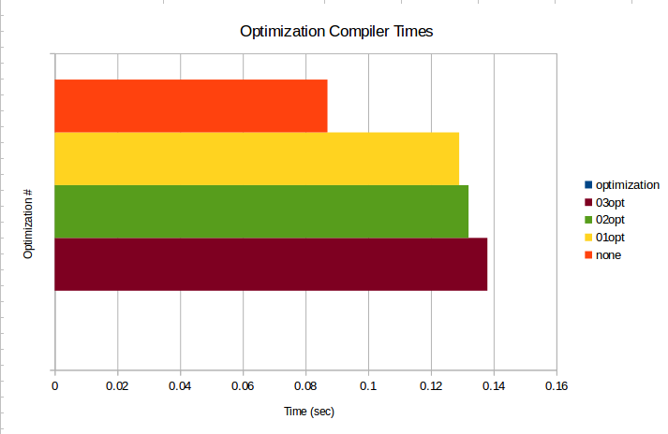  Real time = 0.087s | Real time = 0.129s | Real time = 0.132s | Real time = 0.138s

(11) How much time does the program take to finish with (a) no optimization, (b) with -O1 optimization, (c) with -O2 optimization, and (d) with -O3 optimization? Report the Real time, which is the "wall clock" time. Create both a table and a graph in LibreOffice Calc.
Note: No credit will be given for sloppy graphs that lack X and Y axis labels, a legend, and a title.

No optimization | 01 optimization | 02 optimization | 03 optimization
Real time = 5.199s | Real time = 4.118s | Real time = 2.856s | Real time = 2.729s
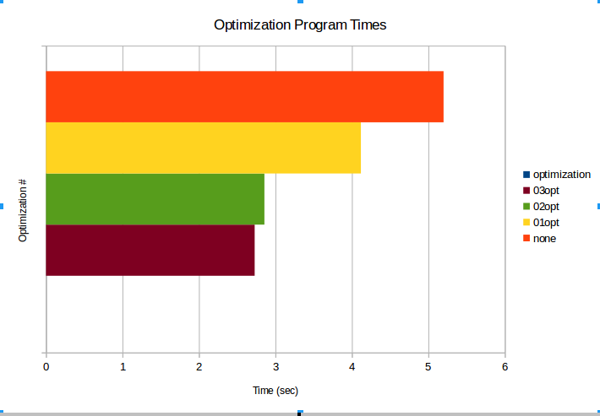

(12) After implementing each function, benchmark it for a variety of data types and mathematical operations. Fill in the table below as you write each function.
Configuration | Vector Size (Elements) | Vector Size (MB) | Time for Integer Add | Time for Integer Multiply | Time for FP (float) ADD | Time for FP (float) Multiply
combine1() | 460000000 | 1754.76 MB | 7.625s
combine2() | 460000000 | 1754.76 MB
combine3() | 460000000 | 1754.76 MB
combine4() | 460000000 | 1754.76 MB
combine5x2() | 460000000 | 1754.76 MB
combine5x3() | 460000000 | 1754.76 MB
combine6() | 460000000 | 1754.76 MB

(13) Using LibreOffice Calc, create a single graph that shows the data in the table created, specifically the four time columns. (You don't need to plot vector size) Note: No credit will be given for a sloppy graph that lack X and Y axis labels, a legend, and a title.

(14) As a reminder, you should be using version control to track your code, and ensure that the final code is checked in along with your report PDF.

